SCALA 1

1)val cards=sc.textFile:

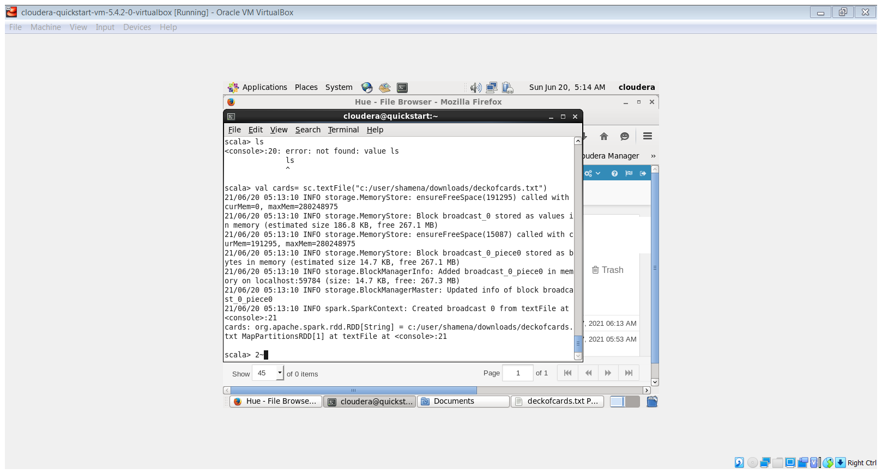

2)cards.collect():

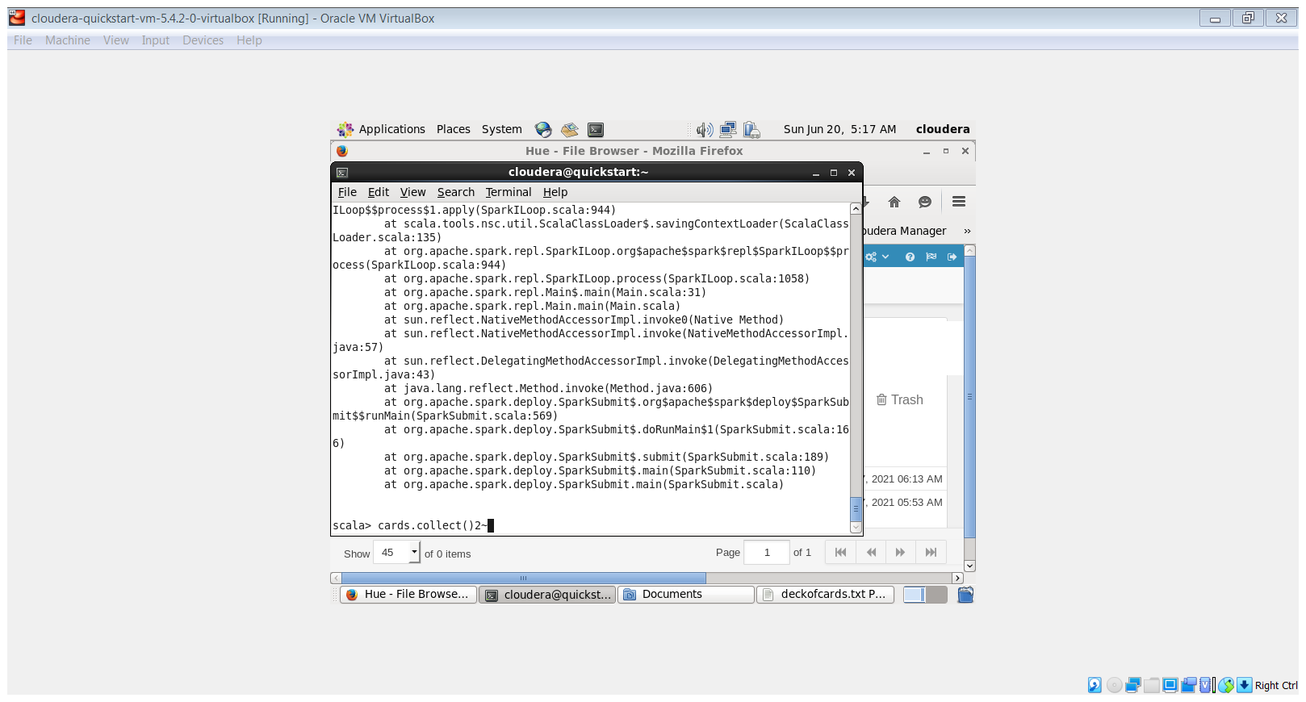

3)cards.count():

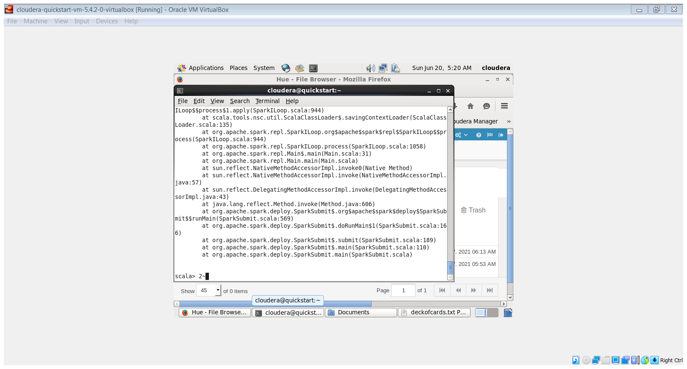

4) val black_queen=cards.filter(line=>line.contains=“BLACK” and line.contains=’Q’):

